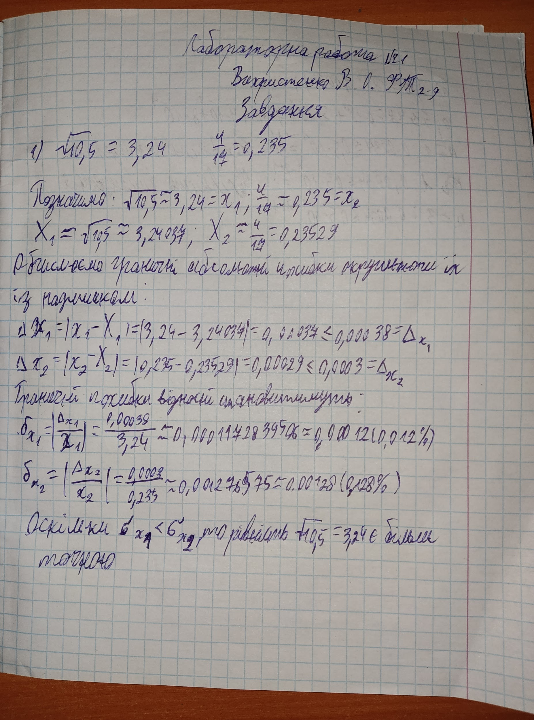
https://colab.research.google.com/drive/1sH1WnHBIBgI7HVb-hKg1q6errfgTQTcD?usp=sharing
